**PIZZA SALES SQL QUERIES**

**A. KPI’s**

**1. Total Revenue:**

SELECT SUM(total_price) AS Total_Revenue FROM pizza_sales;

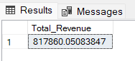

**2. Average Order Value**

SELECT (SUM(total_price) / COUNT(DISTINCT order_id)) AS Avg_order_Value FROM pizza_sales

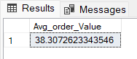

**3. Total Pizzas Sold**

SELECT SUM(quantity) AS Total_pizza_sold FROM pizza_sales

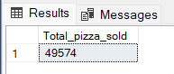

**4. Total Orders**

SELECT COUNT(DISTINCT order_id) AS Total_Orders FROM pizza_sales

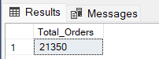

**5. Average Pizzas Per Order**

SELECT (SUM(quantity)/COUNT(DISTINCT order_id) AS Avg_Pizzas_per_order

FROM pizza_sales

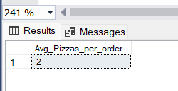

**CAST:-** The CAST() Function coverts a value(of any type) into specified datatype

SELECT CAST(CAST(SUM(quantity) AS DECIMAL(10,2)) /

CAST(COUNT(DISTINCT order_id) AS DECIMAL(10,2)) AS DECIMAL(10,2))

AS Avg_Pizzas_per_order

FROM pizza_sales

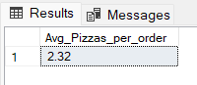

**B. Daily Trend for Total Orders  
DATENAME() Function:-** Argument used to derive the date of the week, month etc

**DW:-** It retrieve day of week as character string like Sunday, Monday. It will convert order_date to day of week

SELECT DATENAME(DW, order_date) AS order_day, COUNT(DISTINCT order_id) AS total_orders

FROM pizza_sales

GROUP BY DATENAME(DW, order_date)

***Output:***

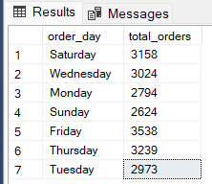

**C. Monthly Trend for Orders**

select DATENAME(MONTH, order_date) as Month_Name, COUNT(DISTINCT order_id) as Total_Orders

from pizza_sales

GROUP BY DATENAME(MONTH, order_date)

***Output***

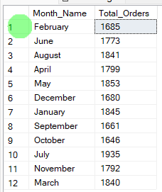

**D. % of Sales by Pizza Category**

SELECT pizza_category, CAST(SUM(total_price) AS DECIMAL(10,2)) as total_revenue,

CAST(SUM(total_price) * 100 / (SELECT SUM(total_price) from pizza_sales) AS DECIMAL(10,2)) AS PCT

FROM pizza_sales

GROUP BY pizza_category

***Explanation***:-

**Numerator: -** SELECT pizza_category, SUM(total_price)* 100 🡨-- With respect to Pizza category total sales

**Denominator: -** SELECT SUM(total_price) from pizza_sales 🡨-- Sales of Entire data

***Output***

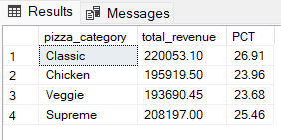

**E. % of Sales by Pizza Size**

SELECT pizza_size, CAST(SUM(total_price) AS DECIMAL(10,2)) as total_revenue,

CAST(SUM(total_price) * 100 / (SELECT SUM(total_price) from pizza_sales) AS DECIMAL(10,2)) AS PCT

FROM pizza_sales

GROUP BY pizza_size

ORDER BY pizza_size

***Output***

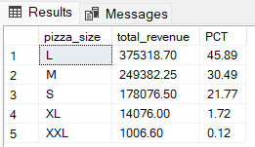

**F. Total Pizzas Sold by Pizza Category**

SELECT pizza_category, SUM(quantity) as Total_Quantity_Sold

FROM pizza_sales

WHERE MONTH(order_date) = 2 <- for February month data

GROUP BY pizza_category

ORDER BY Total_Quantity_Sold DESC

***Output***

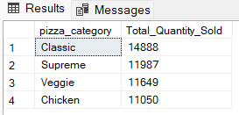

**G. Top 5 Pizzas by Revenue**

SELECT Top 5 pizza_name, SUM(total_price) AS Total_Revenue

FROM pizza_sales

GROUP BY pizza_name

ORDER BY Total_Revenue DESC

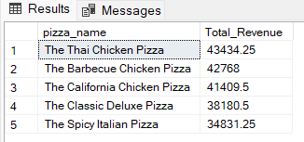

**H. Bottom 5 Pizzas by Revenue**

SELECT Top 5 pizza_name, SUM(total_price) AS Total_Revenue

FROM pizza_sales

GROUP BY pizza_name

ORDER BY Total_Revenue ASC

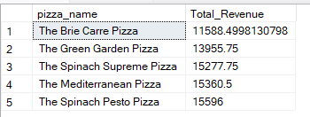

**I. Top 5 Pizzas by Quantity**

SELECT Top 5 pizza_name, SUM(quantity) AS Total_Pizza_Sold

FROM pizza_sales

GROUP BY pizza_name

ORDER BY Total_Pizza_Sold DESC

***Output***

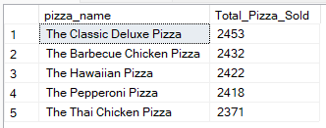

**J. Bottom 5 Pizzas by Quantity**

SELECT TOP 5 pizza_name, SUM(quantity) AS Total_Pizza_Sold

FROM pizza_sales

GROUP BY pizza_name

ORDER BY Total_Pizza_Sold ASC

***Output***

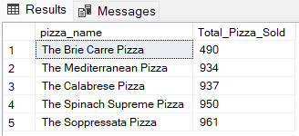

**K. Top 5 Pizzas by Total Orders**

SELECT Top 5 pizza_name, COUNT(DISTINCT order_id) AS Total_Orders

FROM pizza_sales

GROUP BY pizza_name

ORDER BY Total_Orders DESC

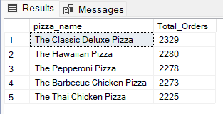

**L. Borrom 5 Pizzas by Total Orders**

SELECT Top 5 pizza_name, COUNT(DISTINCT order_id) AS Total_Orders

FROM pizza_sales

GROUP BY pizza_name

ORDER BY Total_Orders ASC

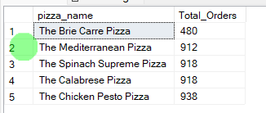

***NOTE***

If you want to apply the (pizza_category or pizza_size) Filters, (Month, Quarter, Week) filters to the above queries we can use WHERE clause. Follow some of below examples

* SELECT Top 5 pizza_name, COUNT(DISTINCT order_id) AS Total_Orders

FROM pizza_sales

WHERE pizza_category = 'Classic'

GROUP BY pizza_name

ORDER BY Total_Orders ASC

* Select DATENAME(MONTH, order_date) as Month_Name, COUNT(DISTINCT order_id) as Total_Orders

From pizza_sales

WHERE MONTH(order_date) = 1 AND DATEPART(QUARTER, order_date) = 1

GROUP BY DATENAME(MONTH, order_date)

*Here MONTH(order_date) = 1 indicates that the output is for the

Month of January

*DatePART(order_date) =1 indicates that the output is for the Quarter 1

*Whenever we applying filters on query it must also be apply on subqueries also